13.52: From Eq. (13.42)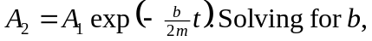
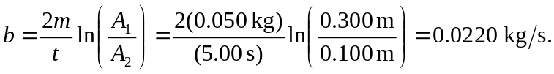
As a check, note that the oscillation frequency is the same as the undamped frequency to 